**How to manually calibrate TandemVu**

* When Auto Calibration failed, try manual calibration instead.
* The recommended number of calibration points are 6 – 9 points. Please carefully choose the scene with appropriate references, and avoid points of being too crowded or scattered.
* It’s recommended to use IE browser and run it as administrator

1. Uncheck “Track” first, to prevent the PTZ from moving around when doing the calibration. (Enable this “Track” means enabling TandemVu’s smart linkage tracking between the fixed lens and PTZ channel). Then select “Manual” and Start Calibration

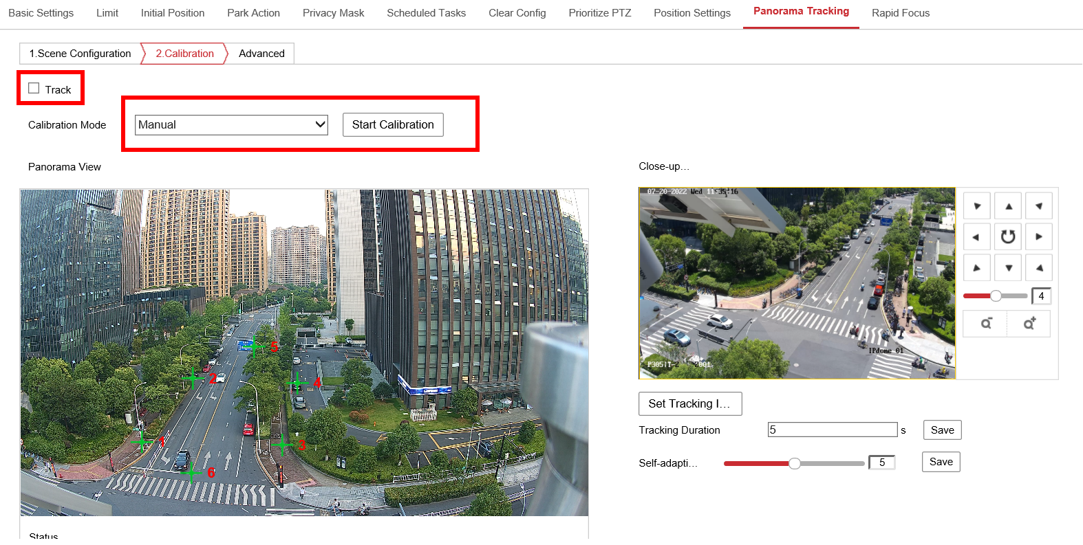

NOTE: for the new web UI (FW 5.8.0 and above), the “Track” function is under VCA – General Settings – Smart Tracking.

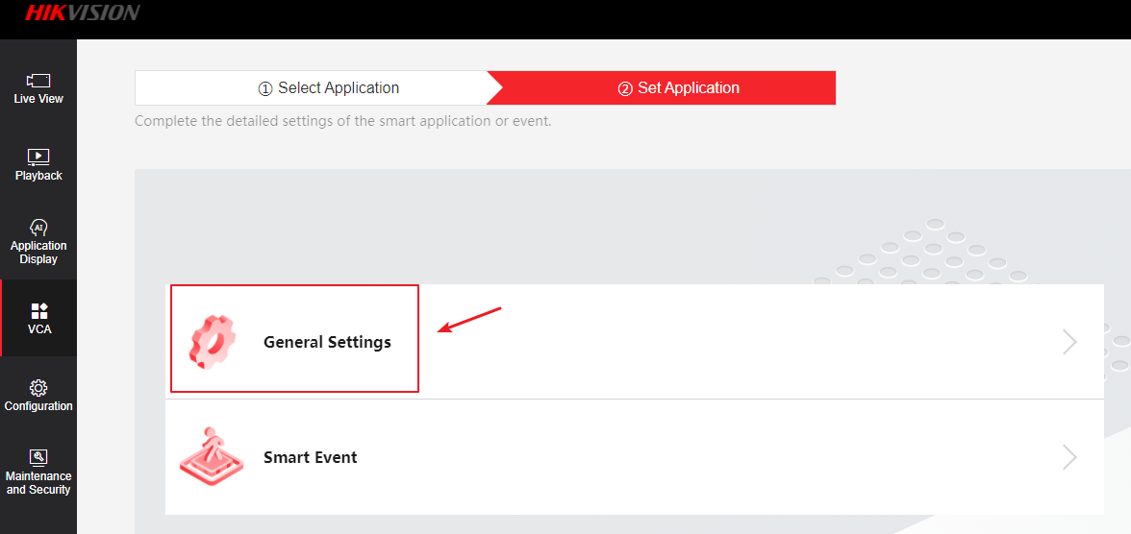

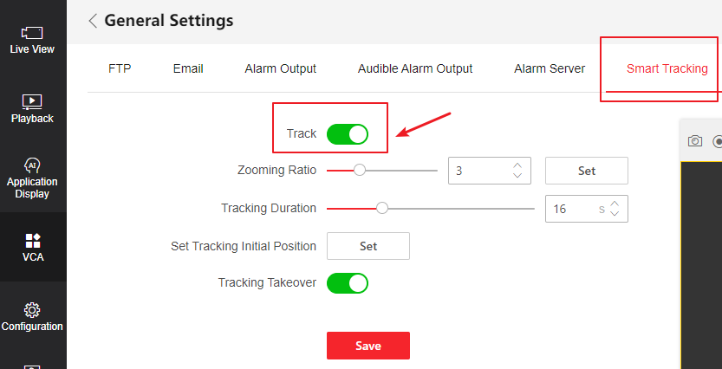

1. Click refresh icon to get the current bullet channel’s view

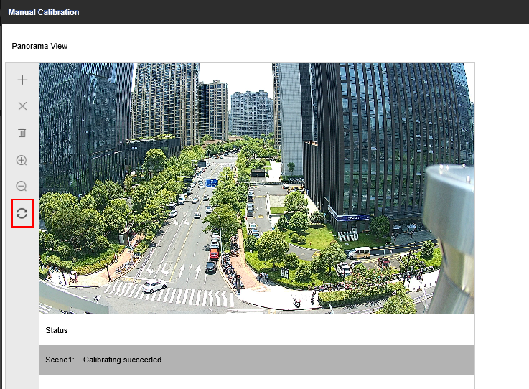

1. The recommended number of calibration points are 6 – 9 points. Please carefully choose the scene with appropriate reference, detailed environment and no obstacles in front of both channels, which can improve the accuracy of calibration.
2. Select a coordinate on the right, click “Add” icon on the left toolbar, a green cross will appear on the bullet channel, move it to an appropriate location on the picture. Then on the PTZ channel, move the PTZ to make sure the green cross on the center of PTZ channel points at the same object/location on the bullet channel.

You can also use 3D Zoom function to make the object on PTZ channel to become the center of the picture: Click 3D Zoom, then move the mouse to PTZ channel and click an object on the picture, that object will automatically become the center of the PTZ channel.

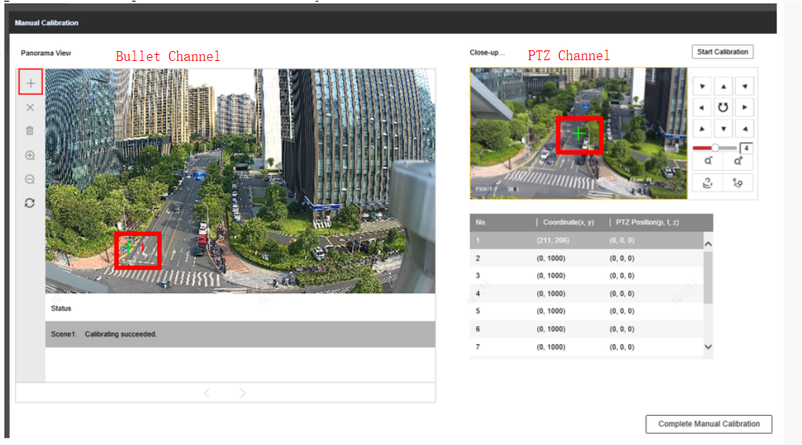

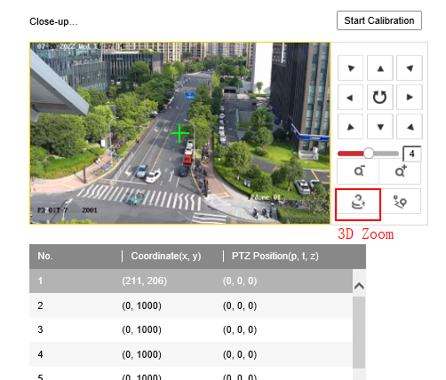

Click 3D Zoom, then click the object in the picture, the object will automatically become the center.

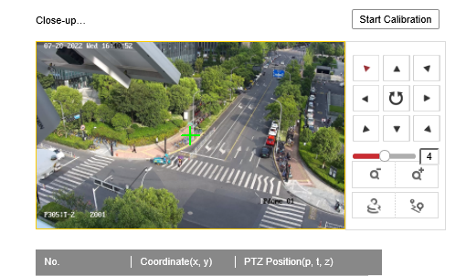  
  
NOTE: in the new WEB UI:

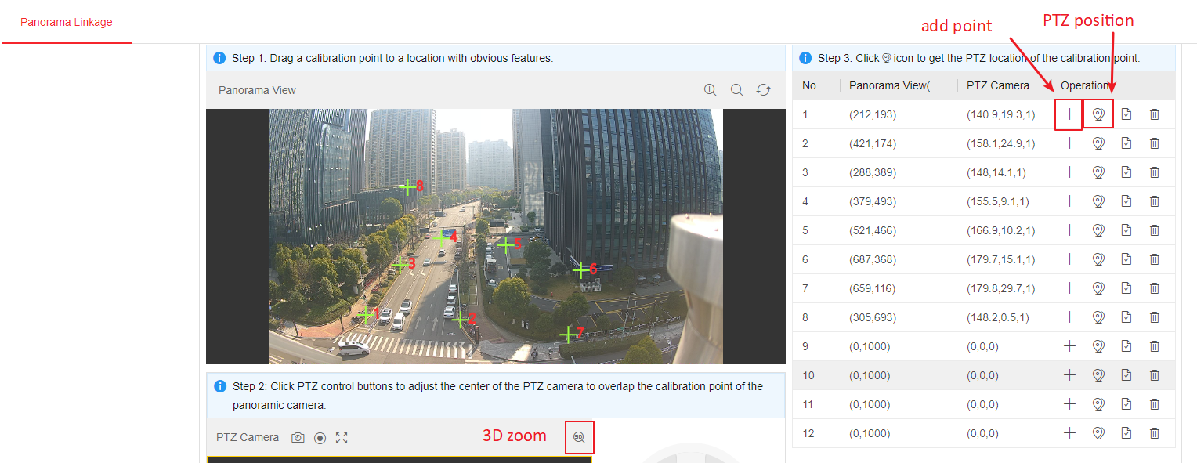

1. After aligning the green cross on both bullet and PTZ channel, click PTZ Position icon to apply the coordination info to the points you just set, then the PTZ Position will be updated.   
   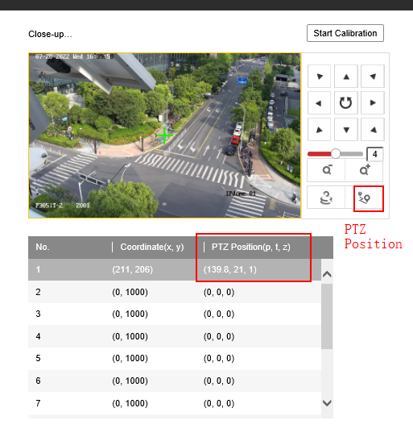
2. That’s for one coordinate. Select the second coordinate, add the second point on bullet channel, and repeat the operations above to calibrate each coordinate.   
   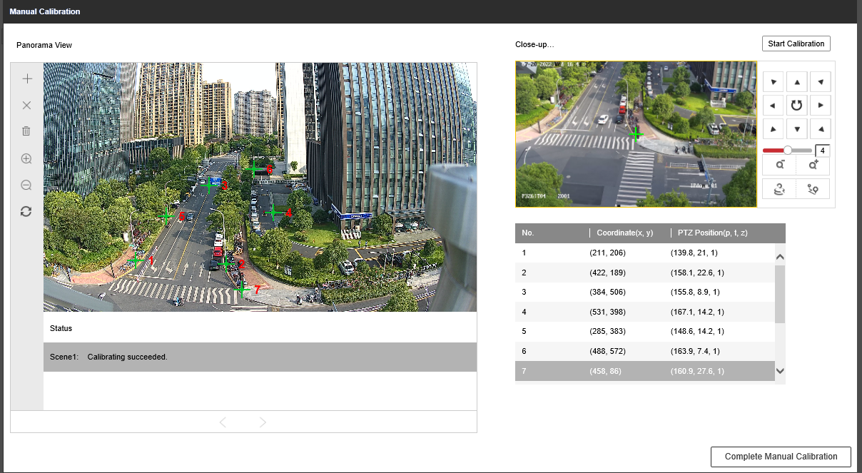
3. After all the coordinates have been calibrated, click Start Calibration on the upper right corner, then click Complete Manual Calibration on the lower right corner. Then this calibration page will exit.  
   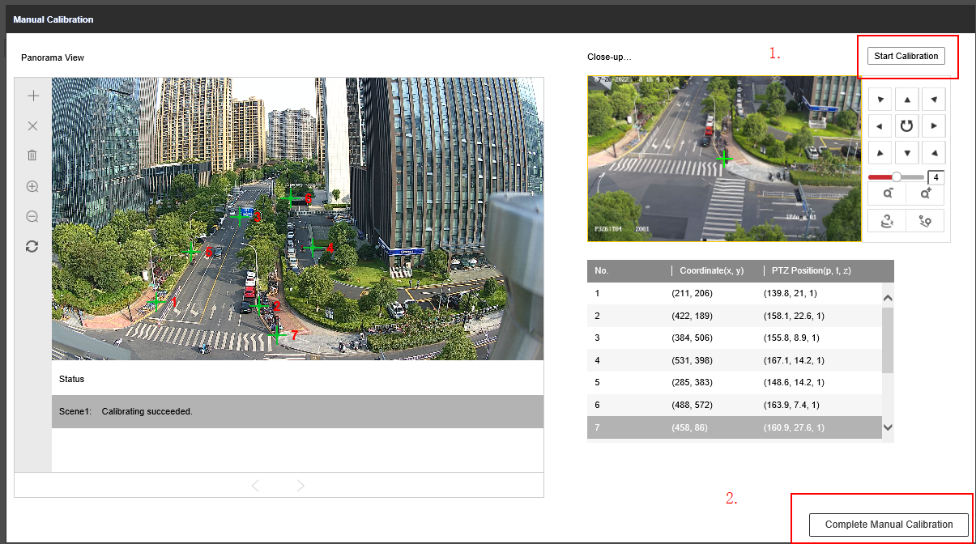
4. Select “track” to enable track again. Manual Calibration finished.

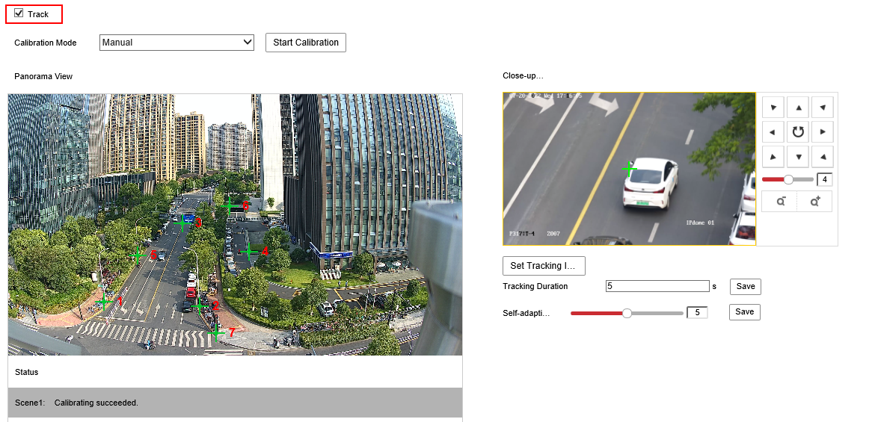

Note: This document use single bullet channel version as demo, which only has 1 Scene. For multi bullet channel product please calibrate under each Scene.

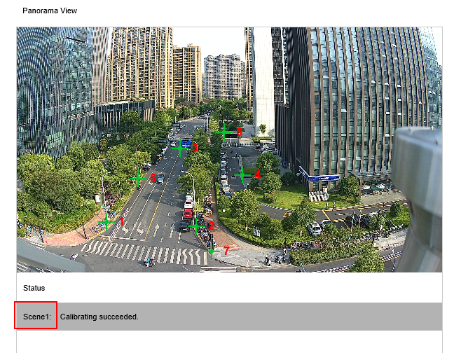

The tracking duration and zooming ratio can be set in here:

